Initial creation of ticket – Documents visible as Copy of Complaint and Copy of Acknowledgment
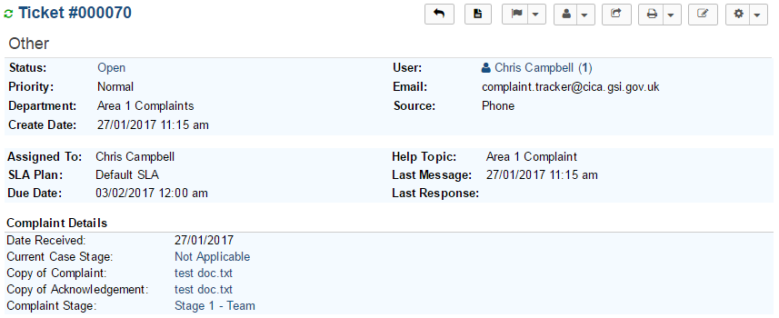
Adding Triage form to ticket
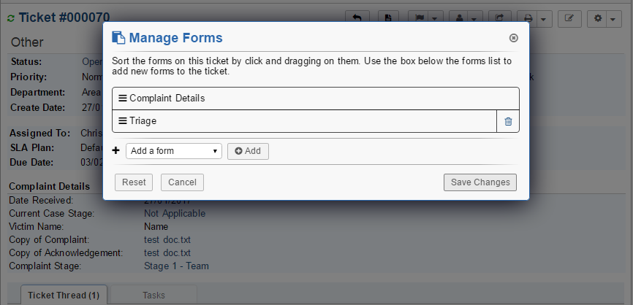

Editing ticket to add Triage details – documents have disappeared
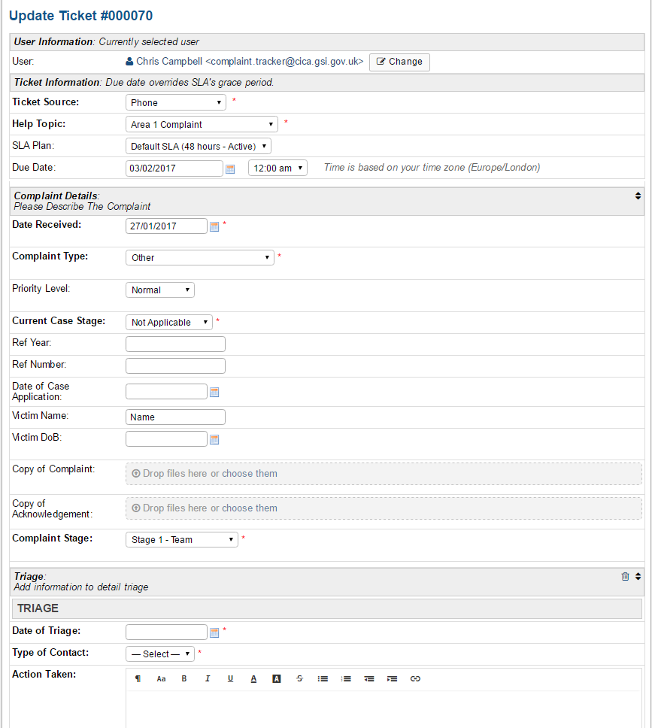

Ticket with document added via internal note – documents persist
