This is what it look like right now

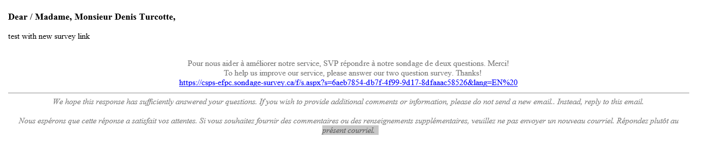

This is the way we would like to see it

