Browsing using <http://requests/scp> and LDAP lookup does not work:

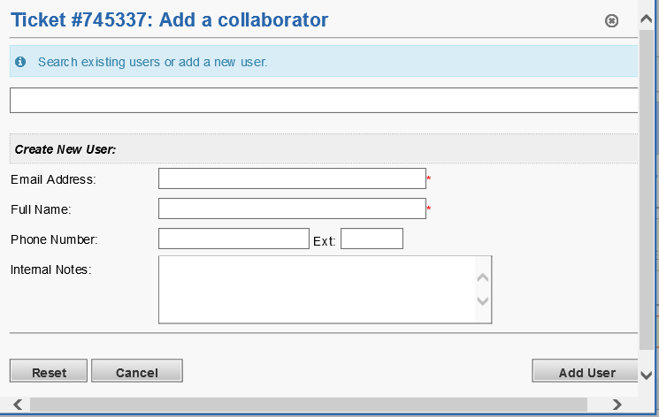

Browsing using <http://192.168.0.xxx/scp> and LDAP lookup works:

