Custom Headers
changes were made to the following to allow for different heading groups
/scp/tickets.php (line ~395)
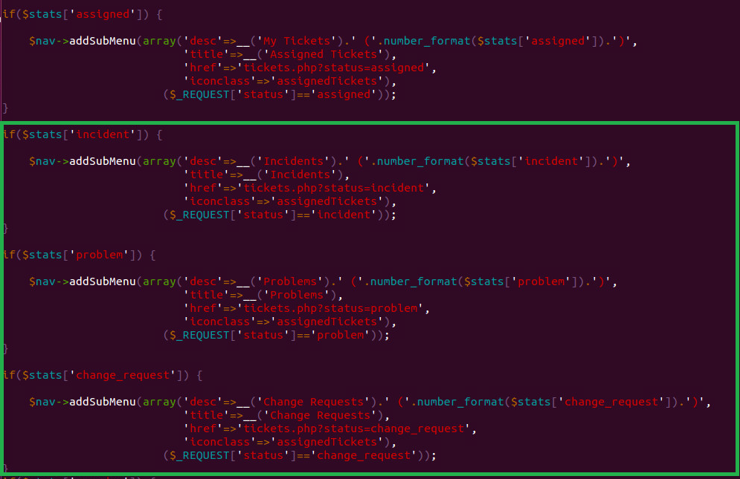

/include/staff/tickets.inc.php (119 for statuses and sub statuses)
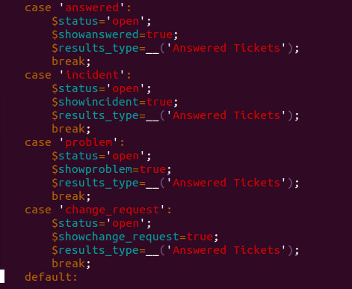

Cannot Find THIS, overloaded sub statuses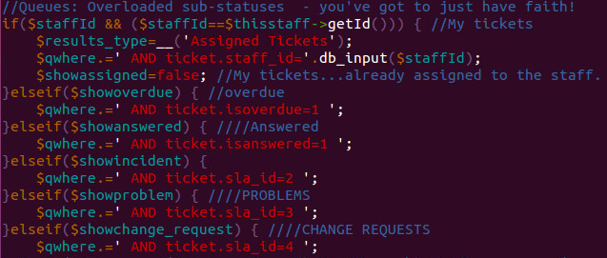

THIS part has also changed in 1.10
changes to include/class.ticket.php
LINE 2150 ish