Ticket income to register a training application

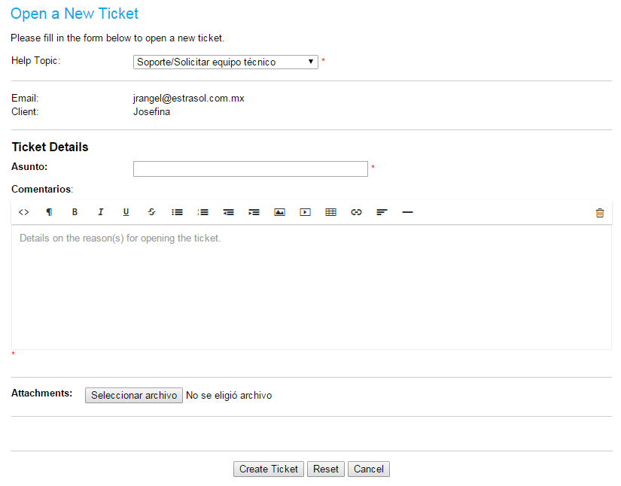

After I select the Help Topic Training option .
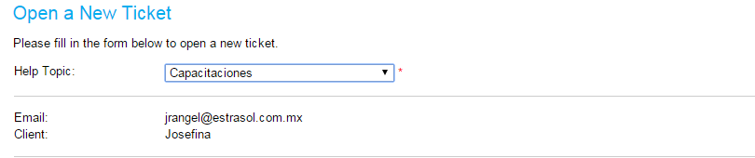

And it shows me the following

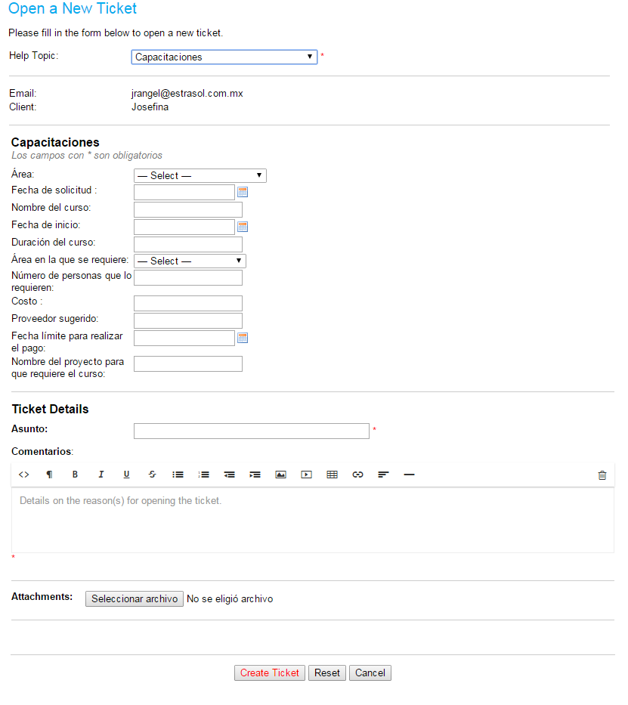

Now I want you to create the ticket is assigned to the person in charge of the area selected in the filter area.

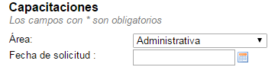

Ie if I select Administrative the ticket was assigned to be in charge of the administrative area.

But if the option selected was Commercial
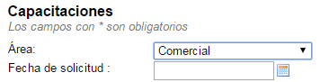

That when creating the ticket is assigned to the manager of the Commercial Area.

