Creating a new task in OS Ticket…
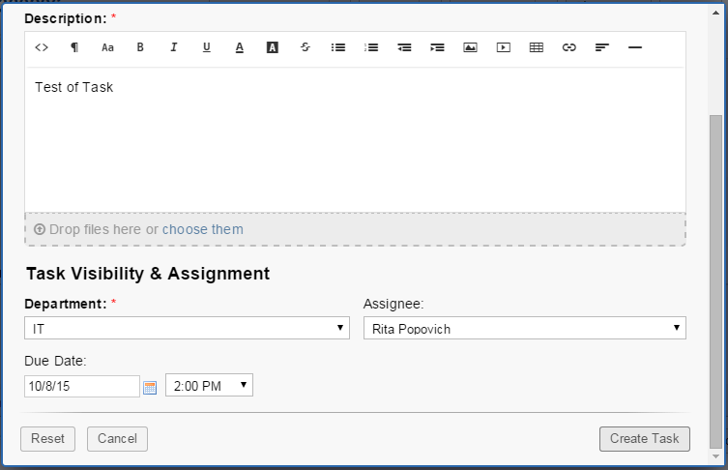
Viewing the task created by opening the task from the task tab open task list…
